www.crossingamusicaljourney.com

Crossing: A Musical Journey is a story of love, loss, redemption and how a Scottish father and son reunited in America in the 1800s. It is an immigrant's tale inspired by the true story of Thomas Morrison and Frances Victory Cox.
The musical features 20 original songs written by Connecticut musicians Mike Bailey and Ron Gletherow. A "small stage" adaptation stars Bailey, Braiden Sunshine. semi-finalist on NBC's The Voice; Greta Loessel, and Galen Donovan. The cast also includes John Lamar, Mike Kickingbear Johnson, Samuel Morrison Bailey, Jim Lampos, Roger Long and Geoff Kaufman.

Michael bailey as George Morrison and Mike Johnson as the Bishop Ian Urquart.
www.crossingamusicaljourney.com

THE STORY

Crossing: A Musical Journey is a based on a true story of love, loss, redemption and reunion in Scotland and America in the 1800s. It features 18 original songs written by local musicians Mike Bailey and Ron Gletherow.
THE STORY
Violette Montressor is a poor, proud French immigrant working in the household of George Morrison, a wealthy Edinburgh businessman. Violette and George's son, Thomas, fall in love and marry in secret. George discovers the secret, has the marriage annulled, and sends Violette away. George and Thomas argue violently, and Thomas leaves Edinburgh, vowing to find Violette.
A few months later, a sickly Violette returns to the Morrison mansion with her newborn son and demands their place in the family. George sees his son in the infant and takes them in. Thomas shows up soon after, but he is unaware that Violette has returned and that he has a son. He cannot bring himself to face his father, and he flees before knocking on the door. Distraught, Thomas sets sail for America, determined to make his fortune and use his wealth to find Violette.
In the next months, Violette and George grow close as daughter and father, and when she dies, George raises the boy as his own son. When Thomas Jr. turns 18, he crosses to America to find his father, who has become a successful mill owner. In a final confrontation, father throws his son out of the mill, believing the story is a con game. Only when Thomas Jr. ends the argument shouting, "Well, that's it, then" -- the same words that George had used to end the argument with his son so many years before -- does Thomas realize the truth. Father and son are reunited.
Thomas Morrison Jr. was the great-great grandfather of Michael Bailey, member of Maggie's Guitar and writer of the song Crossing, which appeared on the 2016 album of the same name. That song tells the Morrison tale.
Themes: Family, social class, privilege, pride, family, love, redemption.
website: www.crossingamusicaljourney.com contains song files, workshop clips and background
www.crossingamusicaljourney.com

CROSSING ON TELEVISION

Above, left, Braiden Sunshine and Julia Helal perform "Sailor" on Better Connecticut. Above right, Galen Donovan performs "Finding My Destiny" on CT Style.
Crossing has been featured on WFSB Channel-3's "Better Connecticut" and WTNH Channel 8's "CT Style."
In addition, songs from Crossing received their world premiere on World Make Music Day, June 21, 2019, when Braiden Sunshine, Julia Helal and Mike Bailey performed on a simulcast from Mashantucket, Connecticut, that was simulcast live across the globe.

Above, left, the live simulcast from Mashantucket of the performance by the cast of Crossing, watched by a crowd gathered at the bandstand in Gera, Germany.
www.crossingamusicaljourney.com

PERFORMANCES

The small stage adaptation of Crossing: A Musical Journey has been in development for the past six years. The current adaptation increases the portability of the musical through short runs with the goal of maximum exposure and audience connection. The production uses a small cast, fully orchestrated tracks, and reduced multimedia to enable it to adapt to a variety of venues and settings.
Venues include the Donald Oat Theater in Norwich, Katharine Hepburn Cultural Arts Center in Old Saybrook, the Lyme Public Hall, and the Hygienic Art Amphitheatre and Friday Night Folk in New London.
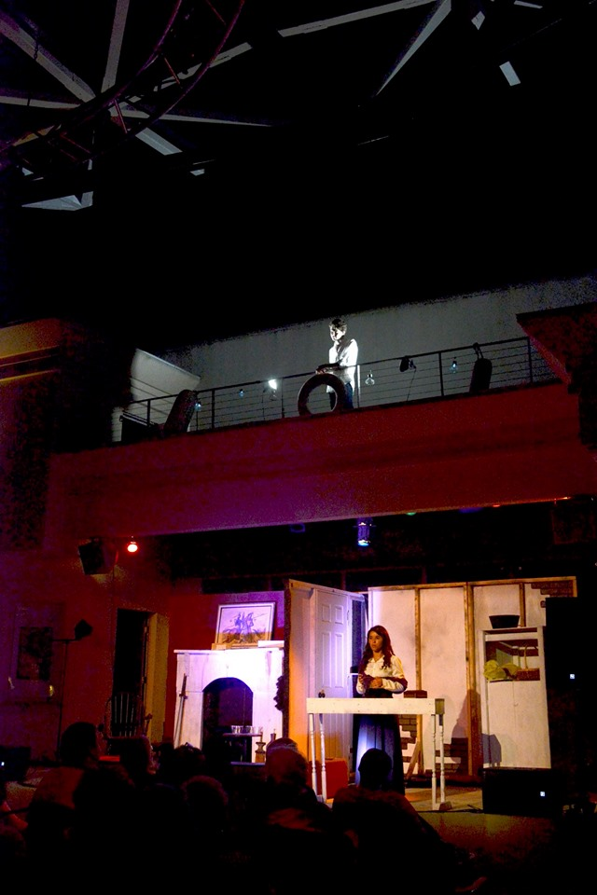
Above, scenes from Crossing Act I.


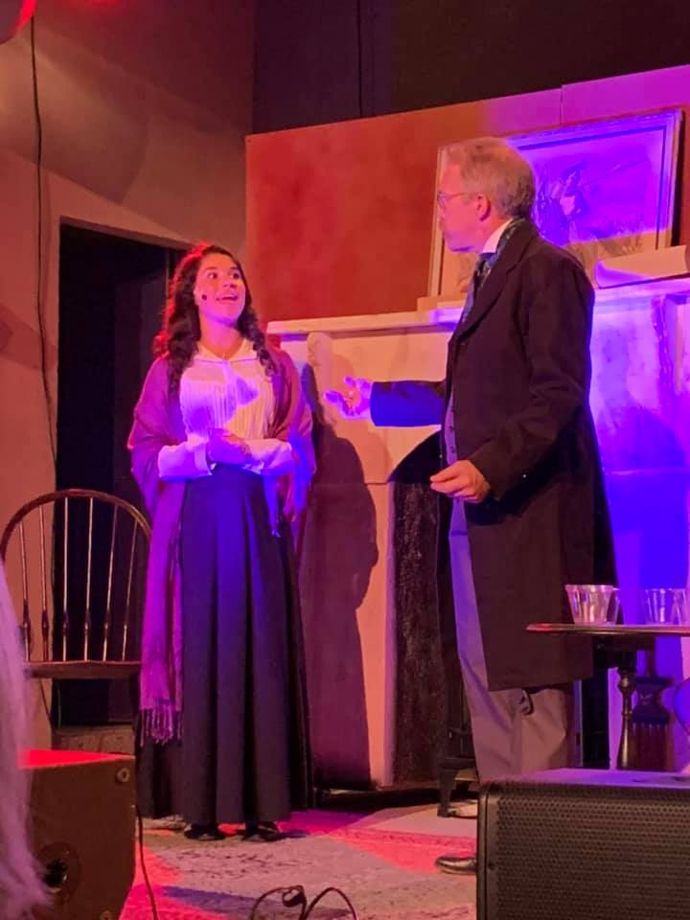
Above, scenes from Crossing Acts I and II.
www.crossingamusicaljourney.com

HISTORY
Crossing: A Musical Journey is inspired by the true story of Thomas Morrison and Frances Victory Cox. They were the great-great grandparents of Mike Bailey, the play's author.
Thomas was one of four sons being raised by a poor widow who immigrated from Scotland. Frances was the youngest daughter of a wealthy Norwich carriage maker.
Thomas left school to work in textile mills at 11 years old. He wanted to be more, so he became an apprentice in a brass finishing shop; one of the shop's customers was John Q. Cox, a prominent carriage maker with shops in Norwich and New London.
Thomas and Frances fell in love and got married. He was 19 and she was 16. They lied about their ages on the marriage license.
When Francis' father found out, he had the marriage annulled and sent his daughter away, probably to Butler Hospital, a mental hospital in Providence. There was one complication: Violette was pregnant. Her father and mother raised the baby as their son, George Cox.
Violette never returned; she left the hospital and married a painter named Franklin Gridley. They had two children. Frank died in the Civil War. Violette died of tuberculosis soon after.
Thomas enlisted in the Union Army during the Civil War, deserted, and eventually made his way to Connecticut as a mill worker.
George discovered that the people raising him were actually his grandparents, not his parents, when he applied for a marriage license at Town Hall. The clerk informed him that his real name was George Morrison.
George left Norwich for Providence in search of his mother, but she had died years earlier. He ended up working in a textile mill in Attleboro. He made a friend of a co-worker, a man named Hervey Gridley. And some time later, George told Hervey about why he had come to Attleboro.

And Hervey said, "I've heard your story before. Your father is a wealthy man." Hervey knew the story because he was Violette's son by a second marriage. George had been working alongside his half-brother -- an incredible coincidence.
George found his father, Thomas, in Thompsonville, Connecticut. Thomas was now foreman of the Hartford Carpet Company. He was indeed a wealthy man. And he accepted George as his son.
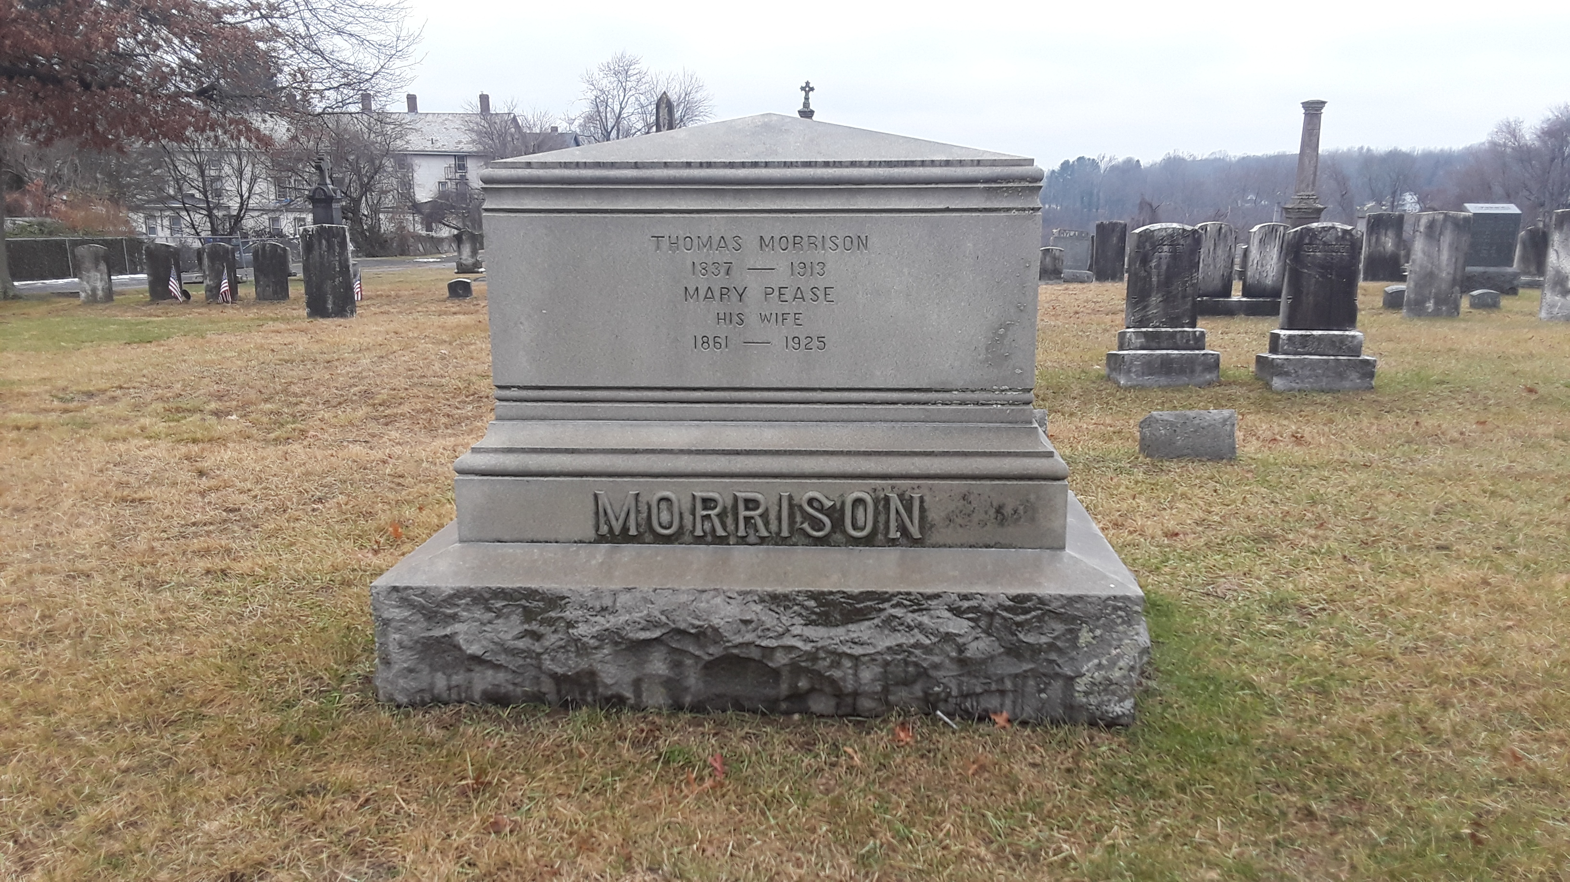
Morrison family plot in Thompsonville, Connecticut

www.crossingamusicaljourney.com

CONTACT INFORMATION

Mike Bailey: 860-861-8040
Ron Gletherow: 860-860-772-5234
email: crossingamusicaljourney@gmail.com
For audio, video, photographs, and historical documents, visit www.crossingamusicaljourney.com

